# Accessing an API

UNISTATS is a UK based service that provides data about higher education institutions in the UK.

They compile data from a number of sources – two of the most import are:

NSS – the national student survey – all final year students in the UK should take part in this survey in their final year.

DLHE – Destination of Leavers from Higher Education – a survey of graduates that asks about employment and salary.

## Get an Access Token

Like many API providers, UNISTATS require each user to have an identifying access token. In some cases this key allows the provider to charge for the service. In this case – for a free service it allows the provider to block or throttle users if required.

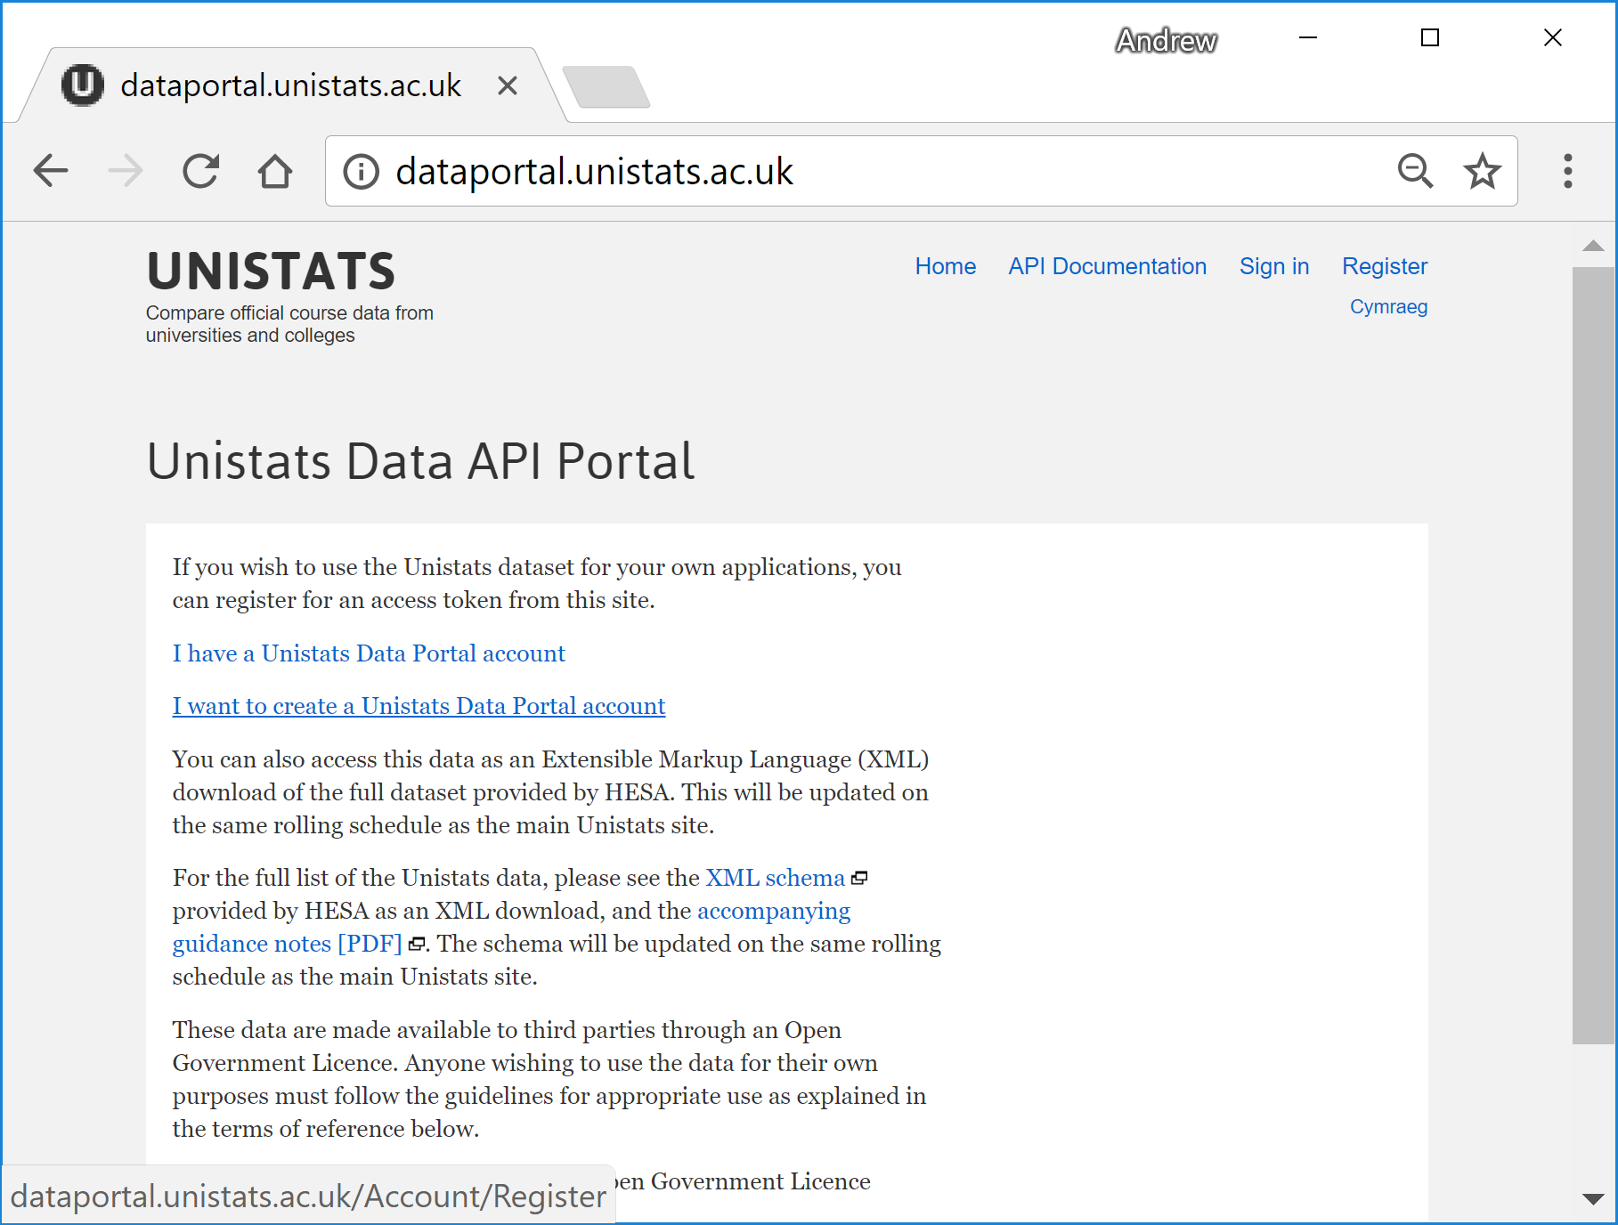

Follow the link “I want to create a Unistats Data Portal Account”, supply an email address and password. You will be show an Access Token – make a note of this token.

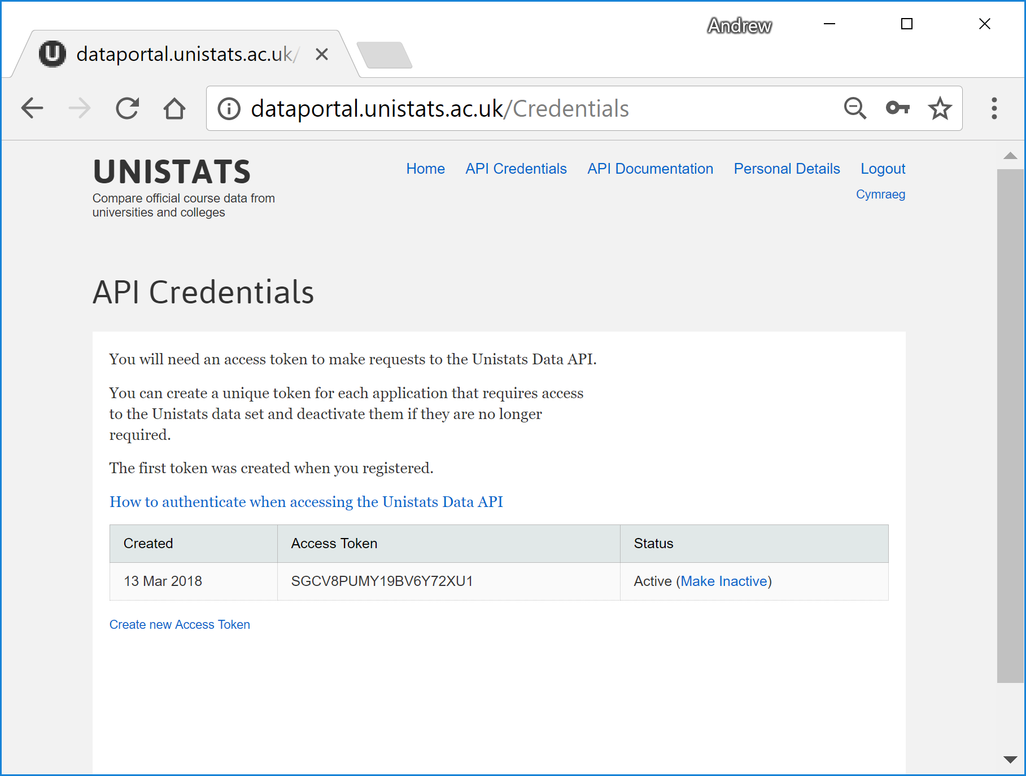

## Your first request

Try the following python program – it should give you the name of the institution 10007772

Use your own access token – not the one shown below.

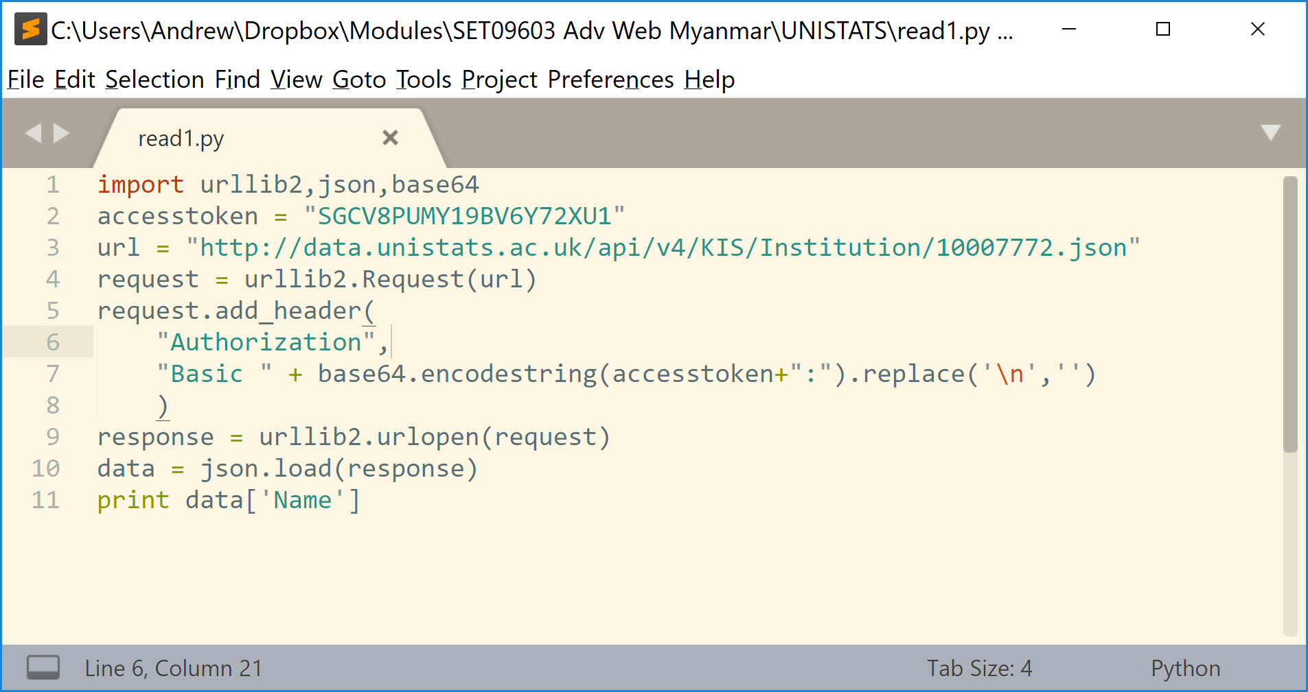

You should try:

1. Find the names of the institutions 10003270, 10007800

**Ans: Imperial College London, University Of The West Of Scotland**

1. You should be able to find the UKPRN for another UK university – “University of Abertay, Dundee”. Check that the number you find is correct. You can use the endpoint /api/v4/KIS/Institutions.json to get a list

**Ans: 10007849**

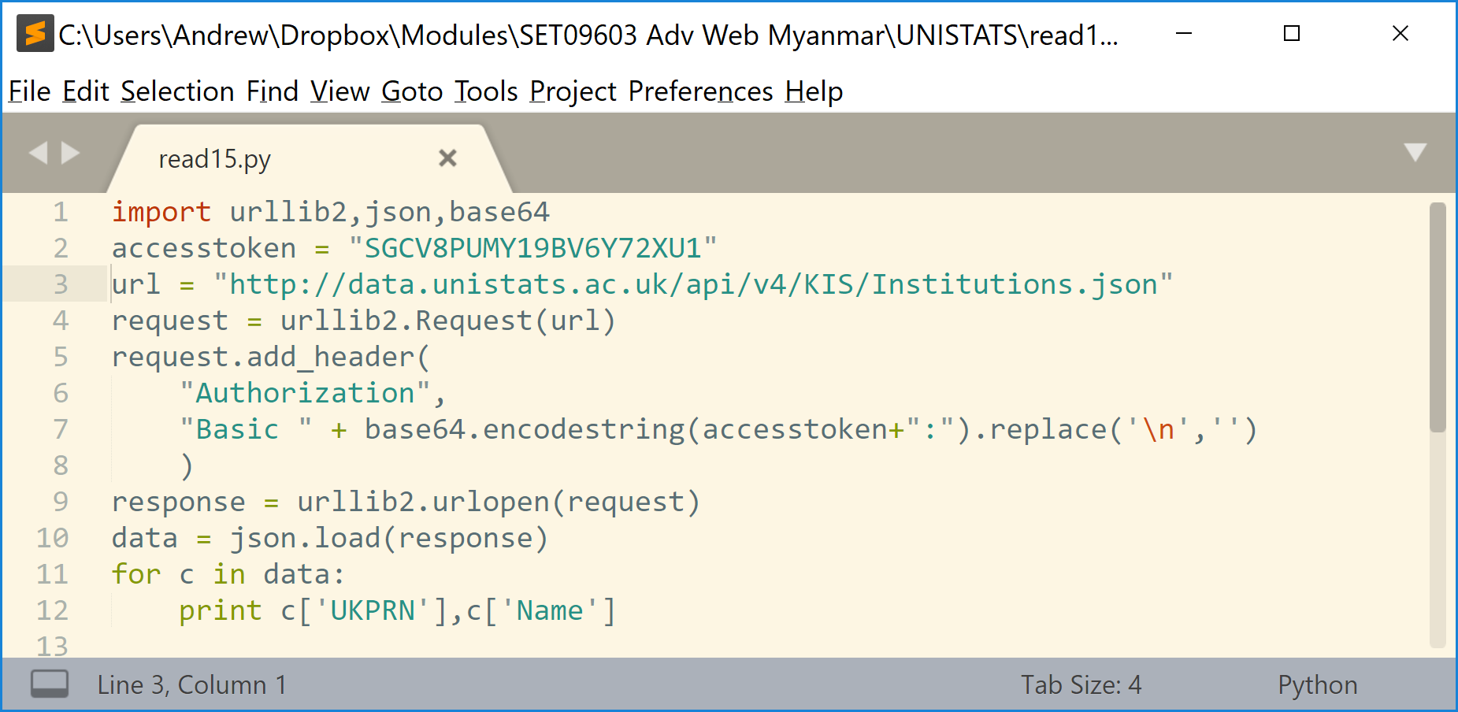

1. Make a note of the error codes you get if the following things are wrong:
   1. The endpoint is wrong (try **Binstitution** instead of **Institution**)
   2. The access token is wrong
   3. The Authorization header is not given

Prove for 3(a)

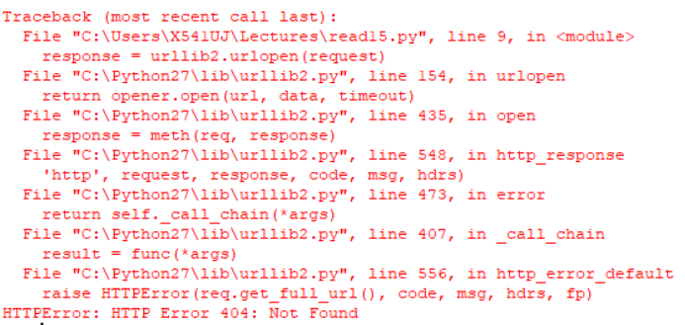

When the endpoint is wrong, “HTTP Error 404: Not Found” will occur.

Prove for 3(b)

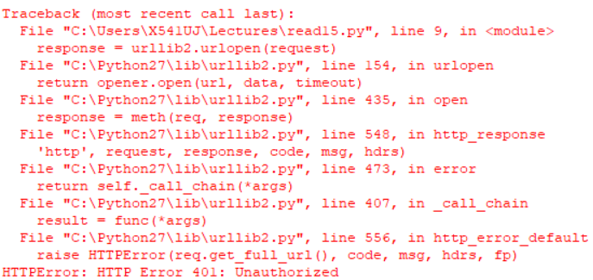

Prove for 3(c)

When the access token is wrong, “HTTP Error 401: Unauthorized” will occur.

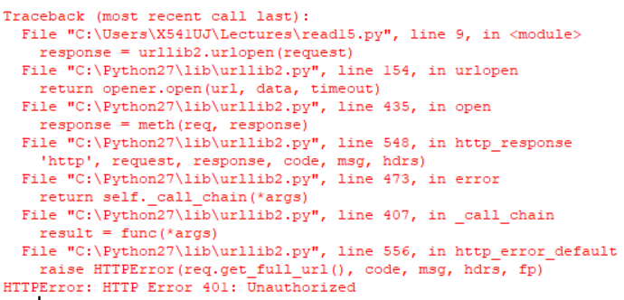

When the Authorization header is not given, “HTTP Error 401: Unauthorized” will occur.

## Get a list of course provided by Edinburgh Napier University

The following program should list page 0 of the courses provided by 10007772:

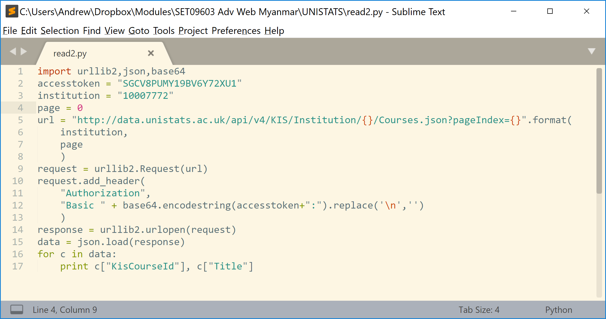

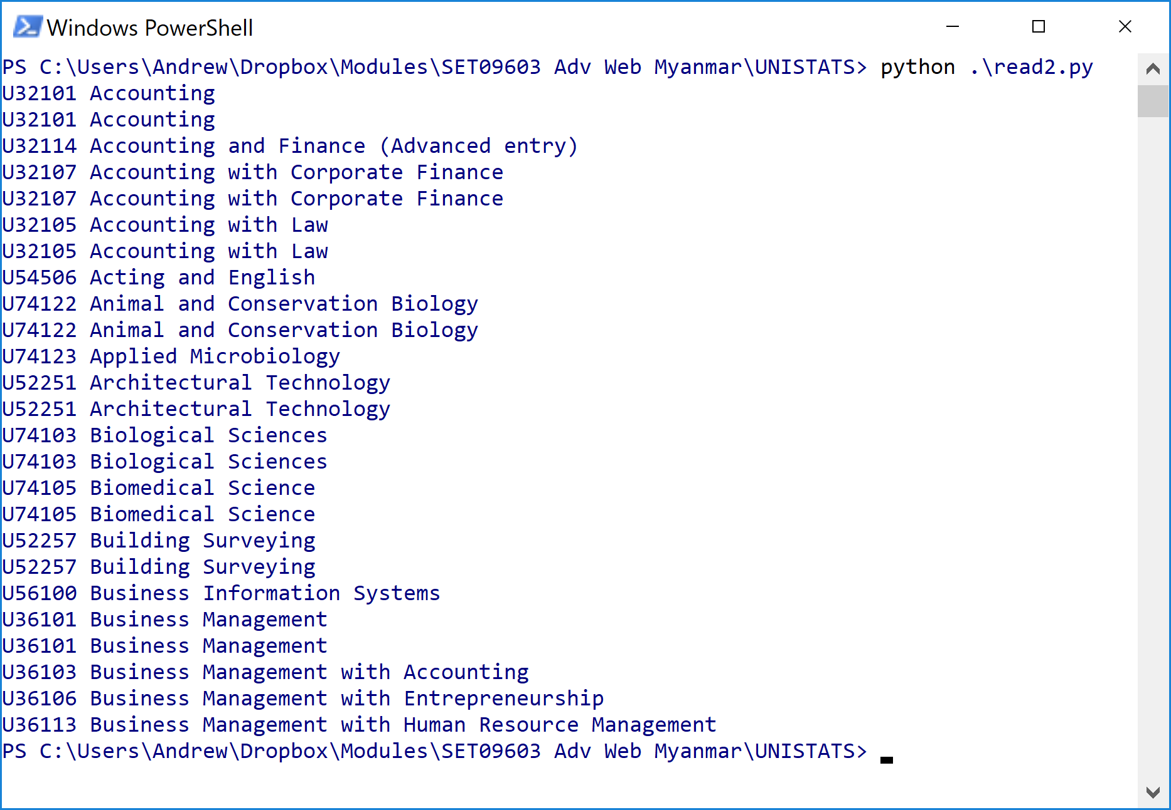

You will have to look at a different page to find your course – try page 1 or 2

For you to try:

1. Find the KisCourseId for **Computing** at Napier

**Ans: (P-1, U56135)**

1. Find the KisCourseId for **Software Engineering** at Napier

**Ans: (P-4, U56119)**

1. Find the KisCourseId for **Accounting** at Abertay

**Ans: (P-0, U32101)**

## Looking at the statistics

The statistics page is the most complicated part of this data set.

You will find information on how to access the statistics at:

<http://dataportal.unistats.ac.uk/Pages/ApiDocumentation>

You will find information about the meaning of the data at:

<https://www.hesa.ac.uk/collection/c17061/unistats_dataset_file_structure>

Use this to find…

1. The median salary 6 months after graduation for Software Engineering students from Napier.

**Ans: 24000**

1. The median salary in the sector for software engineering graduates 40 months after graduation.

**Ans: 30000**

1. The proportion of software engineering students who agree or strongly agree with the statement “Staff are good at explaining things”.

**Ans: 90**

